**Purpose**

The purpose of our project is to historically analyze global inflation rates and their respective national income and unemployment levels, as well as their relation to major world events.

**ETL PROCESS**

EXTRACT

During the data extraction phase, we exported both structured and unstructured raw data from various source locations to our staging area.

*Sources*

Global Annual Inflation Dataset

Source: Data.World

<https://data.world/johnsnowlabs/annual-inflation-by-gdp-deflator>

U.S. Inflation History Dataset

Source: These data were scraped from The Balance’s article, “US Inflation Rate by Year From 1929 to 2023”

<https://www.thebalance.com/u-s-inflation-rate-history-by-year-and-forecast-3306093>

U.S. Monthly CPI Dataset

Source: Kaggle

<https://www.kaggle.com/datasets/neelgajare/usa-cpi-inflation-from-19132022>

Unemployment Dataset

Source: Kaggle

<https://www.kaggle.com/datasets/prasertk/inflation-interest-and-unemployment-rate>

Income Dataset

Source: These data were pulled from the World Bank Databank; Wolrd Development Indicators.

[https://databank.worldbank.org/source/world-development-indicators#](https://databank.worldbank.org/source/world-development-indicators)

*Initial Process*

In the initial phase we imported dependencies, which allowed us to extract, transform, and load our data into our notebook. We imported “*pandas”* for extracting the data from CSV files and a website into data frames with read function, for transforming and cleaning it. From SQLAlchemy we imported functions such as *“create-engine”*and *“inspect”,* which connected our notebook to Postgresql database and its tables, thus allowing us to import clean data into it.

*Reading the CSVs*

For most of our datasets, we were able to use a simple pandas.read to load our CSV files into a Jupyter notebook. Example below.

Our Annual Inflation CSV, however, was too large to load so we had to use compression and zip to read it in.

For our U.S Inflation Rate History dataset, we used pandas.read_html to scrape the appropriate table from the aforementioned webpage.

TRANSFORM

In this phase, we transformed and consolidated our raw data for our intended analytical use. This phase consisted of:

* Filtering, cleansing and de-duplicating the data.
* Changing column headers for consistency, editing text strings, and reformatting columns.
* Using pandas.melt to reformat some of our tables to match the schema of the target data warehouse.

Examples below:

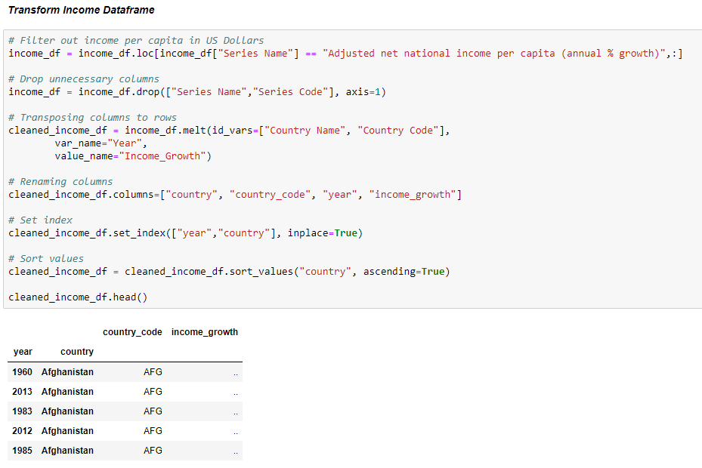

LOAD

### *Schema*

### Once our data frames were cleaned and consolidated, we had the schema we needed to create our database in pgAdmin. We used that schema to ensure appropriate dimensions when creating our tables for each of our original five data frames.

CREATE TABLE annual_inflation(

year INTEGER,

country VARCHAR(50),

country_code VARCHAR(5),

annual_inflation_rate REAL

);

CREATE TABLE us_inflation_hist(

year INTEGER,

business_cycle_and_gdp_growth VARCHAR(50),

country VARCHAR(50),

events_affecting_inflation VARCHAR(50)

);

CREATE TABLE usa_monthly_cpi(

year INTEGER,

country VARCHAR(50),

jan REAL,

feb REAL,

mar REAL,

apr REAL,

may REAL,

jun REAL,

jul REAL,

aug REAL,

sep REAL,

oct REAL,

nov REAL,

dec REAL

);

CREATE TABLE unemployment (

year INTEGER,

country VARCHAR(50),

cpi REAL,

gdp_deflator REAL,

unemp REAL

);

CREATE TABLE income (

year INTEGER,

country VARCHAR(50),

country_code VARCHAR(5),

income_growth REAL

);

### After using pandas to create our database connection in Jupyter, we loaded each data frame into our database, ensuring to replace instead of append. We confirmed our data had been imported accurately by querying each table in our Jupyter notebook.

### 

Finally, back in pgAdmin, we joined the appropriate tables for our intended analytical use. Our original purpose was to historically analyze global inflation rates and their respective national income and unemployment levels, as well as their relation to major world events.

We joined the income and annual_inflation tables to analyze the historical relationship between inflation rates and income levels, by country.

To take a closer look at the U.S. specifically, we combined the usa_monthly_cpi and us_inflation_hist. This new table gives us insight into the U.S. inflation rate in relation to major world events in the last century.

Finally, we combined the income and unemployment tables to analyze global inflation rates, gdp deflator indices, income levels and unemployment rates, by country from 1970-2021 (see below).

